Document Title:
Remote Chess Application
Software Requirements Specification

Module:
COMP3932 – Synoptic Project (EPA)

Version:
1.0

Contents
Contents 2
1. Introduction 6
1.1. Purpose 6
1.2. Scope 6
1.3. Glossary (Definitions, Acronyms & Abbreviations) 7
2. System Overview 7
2.1. Core System Functions 8
2.2. Baseline System: Monolithic 8
2.3. Variant System: Hybrid (Service-Oriented / Event-Driven) 8
3. Functional Requirements 9
3.1. Game Management 9
3.2. Move Handling 9
3.3. State Synchronisation 9
3.4. Persistence 10
3.5. Monitoring & Metrics 10
4. Non-Functional Requirements 10
4.1. Performance 10
4.2. Scalability 10
4.3. Consistency 10
4.4. Fault Tolerance 11
4.5. Reproducibility 11
5. External Interfaces 11
5.1. Client Interface 11
5.2. API Endpoints 11
5.3. Real-time Communication Protocol 11
5.3.1. Message Envelope (applies to all messages) 11
5.3.2. Message Types 12
5.3.2.1. Connection / Session Lifecycle 12
5.3.2.2. Game Creation / Join 12
5.3.2.3 State Synchronisation / Resynchronisation 13
5.3.2.4 Turn-Taking / Move Submission 13
5.3.2.5 Errors 14
5.3.2.6. Ping Pong (optional) 15
5.3.2.7. Rematch 15
5.3.3. State Model 16
5.3.3.1 State Table 16
5.3.3.2 Transition Table 16
5.3.3.3 State Machine Diagram 18
5.3.4. Turn-taking Semantics 18
5.3.4.1. Authoritative Turn Ownership 18
5.3.4.2. Valid Move Conditions 18
5.3.4.3 Turn Progression Rule 19
5.3.4.4 Revision-Based Ordering Control 19
5.3.4.5 Terminal Condition Override 19
5.3.4.6 Rematch Reset Rule 19
5.3.5. Sequencing Rules 20
5.3.5.1 Message Legality (based on current state) 20
5.3.5.2 Message Ordering Within a Turn 20
5.3.5.3 Single Active Move Constraint 20
5.3.5.4 Rematch Sequencing Constraint 20
5.3.5.5 Reconnection Ordering 21
5.3.5.6 Determinism Guarantee 21
5.3.6. Error Handling 21
5.3.6.1 State Violation Errors 21
5.3.6.2 Turn Authority Errors 21
5.3.6.3 Revision Mismatch Errors 21
5.3.6.4 Illegal Move Errors 22
5.3.6.5 Rematch Availability Errors 22
5.3.6.6 Disconnection 22
6. Message Catalogue 22
6.1. HELLO 22
6.2. WELCOME 23
6.3. GAME_CREATE 24
6.4. GAME_CREATED 25
6.5. GAME_JOIN 26
6.6. GAME_JOINED 27
6.7. GAME_START 28
6.8. STATE_SYNC_REQUEST 28
6.9. STATE_SYNC 29
6.10. MOVE_SUBMIT 30
6.11. MOVE_ACCEPTED 32
6.12. MOVE_REJECTED 32
6.13. STATE_UPDATE 33
6.14. GAME_CONCLUDED 35
6.15. PLAYER_LEFT 35
6.16. ERROR 36
6.17. REMATCH_REQUEST 37
6.18. REMATCH_DECLINE 38
6.19 RESIGN 39
7. Dependency Diagrams 1
7.1. Monolith 1
7.2. Hybrid 1
8. Database Entity Relationship Diagram 2
9. Sequence Diagrams 3
9.1. Full Detail 3
9.2 High-level 4
9.3 Simplified 5
9.4 Full Detail (decomposed into 4 phases) 6
10. Evaluation Requirements 1
10.1. Workloads 1
10.2. Metrics Collection 1
11. Limitations 1

Introduction

Purpose
This Software Requirements Specification (SRS) defines the functional and non-functional requirements for a web-based, real-time, two-player chess application.
The purpose of this system is not to optimise gameplay features or provide a production-ready gaming platform, but to serve as a controlled experimental platform for evaluating architectural design choices in interactive distributed systems. Specifically, the system will be implemented in two architectural variants (a monolithic version, and a hybrid service-oriented / event-driven hybrid) to enable comparative analysis of performance, consistency, scalability and fault tolerance
This document provides a clear and testable specification to guide implementation and subsequent evaluation

Scope
The system enables two remote users to:
- Create and join a chess session
- Submit legal chess moves
- Receive real-time updates of shared board state
- Resume games following service interruption / restart
- Propose a rematch upon successful completion of a game
The system will:
- Enforce official chess rules
- Maintain an authoritative server-side game state
- Persist game state in a relational database
- Expose monitoring endpoints for evaluation
The system will not:
- Provide AI opponents
- Include user authentication beyond session identification
- Include advanced UI features or matchmaking services
- Operate at global, cloud-scale deployment
The application is intentionally constrained to small-to-medium scale deployment in order to isolate architectural behaviour under controlled conditions

Glossary (Definitions, Acronyms & Abbreviations)
Examples:
- Architecture Variant: A specific structural implementation of the system
- Authoritative State: The single, trusted game state maintained by the server
- Fault Tolerance: The systems ability to continue operating despite component failure
- FEN (Forsyth-Edwards Notation): A standard text representation of a chess board state
- Latency (P50 / P95 / P99 (50th, 95th and 99th percentiles)): Time taken for a move to propagate
- MVP (Minimum Viable Product): The baseline functional implementation used as a reference architecture
- Pub/Sub (Publish / Subscribe): A communication pattern where one component sends a message to a shared channel, and other components receive it by subscribing to that channel.
- REST (Representational State Transfer): An HTTP-based architectural style used for resource-oriented APIs
- SPA (Single-Page Application): A web application architecture in which content is dynamically updated within a single browser page without requiring full page reloads
- Throughput: The number of moves processed per unit of time
- UCI (Universal Chess Interface): A standard text-based protocol for representing chess moves and communicating with chess engines
- WebSocket (WS): A persistent, bidirectional communication protocol used for real-time message exchange

System Overview
The system is a web-based distributed application enabling two remote players to participate in a chess game with real-time state synchronisation. Clients connect via persistent WebSocket connections to a server-side system that maintains an authoritative game state.
All player actions are validated server-side before being applied, ensuring deterministic progression of game state and preventing divergence between clients. State updates are broadcast to all participants following each accepted move.
Two architectural variants are implemented to support controlled evaluation:
- A monolithic architecture in which all responsibilities are contained within a single Node.js process, using in-process event-driven coordination.

- A hybrid service-oriented and event-driven architecture, in which responsibilities are decomposed into multiple services that communicate via asynchronous messaging (Redis Pub/Sub), while maintaining a single authoritative game state component.
Both variants share identical functional behaviour, communication protocols, and persistence mechanisms, enabling architectural structure to be evaluated in isolation.

Core System Functions
- Creation and joining of game sessions between two remote players
- Validation of submitted chess moves against official rules
- Maintenance of a single authoritative game state
- Real-time broadcast of state updates to connected clients
- Persistence of game state and move history
- Recovery of session state following disconnection or restart
- Explore of system metrics for performance evaluation

Baseline System: Monolithic
Implemented as a single-process Node.js application, adopting an event-driven execution model, where incoming client messages are handled asynchronously within the same process. All coordination between components, including session management, move validation, and state broadcasting, occurs via in-process function calls and internal event dispatching.
- Single Node.js runtime
- In-process event-driven coordination
- WebSocket-based real-time communication
- Shared-memory state management
- PostgreSQL persistence layer

Variant System: Hybrid (Service-Oriented / Event-Driven)
Decomposed into 3 distributed services:
  - Connection / Gateway: responsible for WS connection management, client ID, and message routing
  - Session / Lifecycle: responsible for session creation, player assignment, and lifecycle management
  - Game State / Moves: responsible for maintaining the authoritative game state, validating moves, and enforcing turn-taking semantics
Inter-service communication is implemented using Redis Pub/Sub, enabling asynchronous message exchange between the services.

Functional Requirements

Game Management
- FR 001 - The system must allow a user to create a new game session.
- FR 002 - The system must generate a unique identifier for each new game session
- FR 003 - The system must allow a second user to join an existing game session using its identifier (or password)
- FR 004 - The system must assign one player the white pieces and the other player the black pieces
- FR 005 - The system must prevent more than two players from joining a single game
- FR 006 - The system must initialise the board in the standard chess starting position

Move Handling
- FR 007 - The system must accept moves submitted in UCI format
- FR 008 - The system must validate every submitted move against official chess rules
- FR 009 - The system must reject any move that is illegal
- FR 010 - The system must prevent a player from moving out of turn
- FR 011 - The system must update the authoritative game state after each valid move
- FR 012 - The system must detect check conditions
- FR 013 - The system must detect checkmate conditions
- FR 014 - The system must detect stalemate conditions
- FR 015 - The system shall terminate a game when a checkmate or stalemate condition is reached.

3.3. State Synchronisation
- FR 016 - The system must broadcast updated game state to both connected clients after each valid move
- FR 017 - The system must represent the current board state using FEN notation
- FR 018 - The system must transmit both the most recent move, and the current FEN string to clients
- FR 019 - The system must ensure that client-side board state matches the authoritative server state
- FR 020 -The system must resend the current FEN state to a client upon reconnection

3.4. Persistence
- FR 021 - The system must persist the current FEN state (database and/or local memory)
- FR 022 - The system must persist the game history for each game session, including moves, players, result, status, etc. (database and/or local memory)
- FR 023 - The system must restore the latest stored state after server restart (database and/or local memory)

3.5. Monitoring & Metrics
- FR 024 - The system must record timestamps for move receipt and state broadcast
- FR 025 - The system shall expose a /metrics endpoint for performance data retrieval
- FR 026 - The system must expose a /health endpoint indicating service availability

4. Non-Functional Requirements

4.1. Performance
- NFR 001 - The system must achieve a median (p50) move propagation latency of <= 100ms under baseline workload conditions
- NFR 002 - The system must record p95 and p99 latency values for all experimental runs
- NFR 003 - The system must support at least one concurrent game session without performance degradation
- NFR 004 - The system must measure throughput in moves processed per second

4.2. Scalability
- NFR 005 - The system must be evaluated under increasing numbers of concurrent sessions
- NFR 006 - The system must record how latency changes as concurrency increases
- NFR 007 - The system must record how CPU and memory usage change as concurrency increases

4.3. Consistency
- NFR 008 - The system must maintain a single authoritative game service
- NFR 009 - The system must prevent state divergence between clients
- NFR 010 - The system must prevent duplicate move submission
- NFR 011 - The system must prevent out-of-order move execution

4.4. Fault Tolerance
- NFR 012 - The system must log behaviour when a service is terminated unexpectedly
- NFR 013 - The system must log behaviour when artificial network delay is introduced
- NFR 014 - The system must record recovery time after a service restart

4.5. Reproducibility
- NFR 015 - The system must fix dependency versions using a lockfile
- NFR 016 - The system must document all environment configuration parameters
- NFR 017 - The system must allow identical test workloads to be re-executed

5. External Interfaces

5.1. Client Interface
- React-based SPA
- Board rendered from FEN
- WebSocket communication via the browser WebSocket API

5.2. API Endpoints
- POST /game
- GET /health
- GET /metrics

5.3. Real-time Communication Protocol

5.3.1. Message Envelope (applies to all messages)
All messages must be JSON objects:
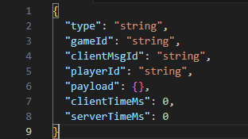
Figure 1 - client-server message envelope (serverTimeMs only for server-client messages)
Notes:
- clientMsgId enables idempotency, where reprocessing an identical message has no additional effect on system state beyond the first execution, thereby supporting duplicate detection.
- clientTimeMs and serverTimeMs give good latency measurements without clock sync assumptions (can still compute server-side duration reliably)
- For brevity, message payload examples omit the common envelope fields defined above

5.3.2. Message Types

5.3.2.1. Connection / Session Lifecycle
Occurs immediately after WebSocket connection, and before any game-related messages are processed.
- Client → Server: HELLO
Purpose: identify client, then optionally resume
Payload: 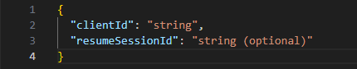
- Server → Client: WELCOME
Payload: 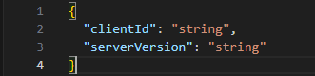

5.3.2.2. Game Creation / Join
- Client → Server: GAME_CREATE
Payload: empty
- Server → Client: GAME_CREATED
Payload:
- Client → Server: GAME_JOIN
Payload:
- Server → Client: GAME_JOINED
Payload: 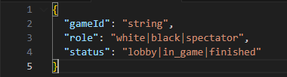
- Server → Client: (broadcast to game): GAME_START
Purpose: Sent when two players are present and roles (black / white) are assigned
Payload: 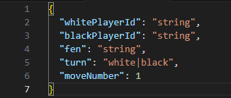

State Synchronisation / Resynchronisation
- Client → Server: STATE_SYNC_REQUEST
For when reconnecting or if client suspects clock drift
Payload:
Purpose: If server’s current revision != expectedRevision, then the client is stale (missed an update, reconnected late, or double-submitted, etc.). The server can reject with STALE_CLIENT_STATE and send STATE_SYNC. This is a simple guard against out-of-order / duplicated / stale moves and makes correctness testing easier.
Note: revision will increment after every successful MOVE_SUBMIT, so one full game round = 2 increments (1 turn (increment) per player)
- Server → Client: STATE_SYNC
Payload: 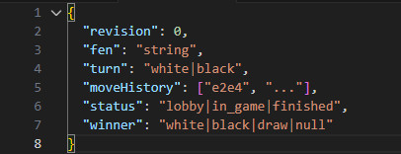

5.3.2.4 Turn-Taking / Move Submission
- Client → Server: MOVE_SUBMIT
Payload: 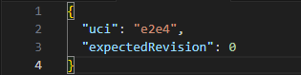
- Server → Client: MOVE_ACCEPTED
Sent to submitting client only, to confirm receipt/understanding of message (ack)
Payload: 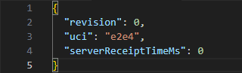
- Server → Client (broadcast): STATE_UPDATE
Sent to both players (and spectators if functionality added in future) after the move is applied and persisted
Payload: 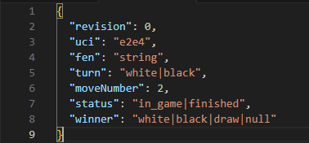
Note: separating MOVE_ACCEPTED and STATE_UPDATE allows for atomised observation(?). MOVE_ACCEPTED is the server receipt timestamp anchor, and STATUS_UPDATE is the authoritative propagation event (client-perceived latency)

5.3.2.5 Errors
- Server → Client: ERROR
Payload: 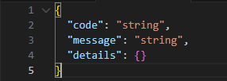
List of error codes (non-exhaustive, update as required):
- GAME_NOT_FOUND
- GAME_FULL
- NOT_IN_GAME
- NOT_YOUR_TURN
- ILLEGAL_MOVE
- STALE_CLIENT_STATE (expectedRevision != current revision)
- DUPLICATE_MESSAGE (clientMsgId already processed)
- INVALID_MESSAGE_FORMAT
- INTERNAL_ERROR

5.3.2.6. Ping Pong (optional)
1. Server → Client: PING
Payload: 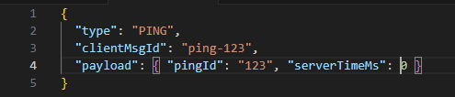
2. Client → Server: PONG
Payload: 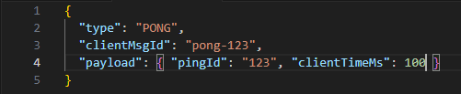
Purpose: Server can compute approximate round-trip-time (RTT) by recording when it sent PING and when it received PONG with the same pingId

5.3.2.7. Rematch
1. Client → Server: REMATCH_REQUEST
Payload: 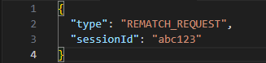
2. Server → Clients: REMATCH_STATUS
Payload: 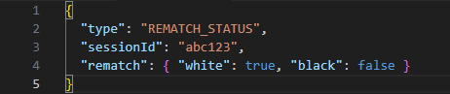
3. Server → Clients: REMATCH_START
Payload: 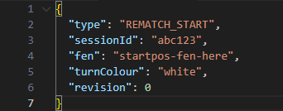

5.3.3. State Model

5.3.3.1 State Table
State | Description | Invariants (must always be true) | Permitted Messages | Notes
NO SESSION (S0) | N/A | GAME_CREATE | N/A | Initial system state
WAITING FOR  PLAYERS  (S1) | Session exists but fewer than 2 players connected | fen = START_FEN,  revision = 0, turnColour = null  One player slot may be empty | GAME_JOIN, DISCONNECT,  RECONNECT | Game cannot begin until both players assigned
IN PROGRESS  (S2) | Active game session between two players | Both player.white and player.black assigned fen represents valid board state.  revision >= 0, turnColour ∈ {white, black} | MOVE_SUBMIT, DISCONNECT, RECONNECT,  RESIGN | Turn alternates after each valid move.
FINISHED  (S3) | Game has ended (checkmate or stalemate) | Result defined,  fen is terminal position,  revision fixed unless rematch occurs | REMATCH_REQUEST,  REMATCH_DECLINE, RECONNECT | No further moves permitted

5.3.3.2 Transition Table
ID | From State | Trigger (message) | Guard (condition) | Server Actions | To State | Emits
T1 | N/A | GAME_CREATE | N/A | Create session, default initialisation:  WAITING_FOR_PLAYERS, fen = START_FEN, revision = 0, rematch = {false, false} | S1 | GAME_CREATED, STATE_SYNC
T2 | S1 | GAME_JOIN | Session exists AND slot available | Assign joining player to remaining colour | S1 | PLAYER_JOINED, STATE_SYNC
T3 | S1 | (internal condition) | Player.white && player.black | Set turnColour = “white” | S2 | GAME_START, STATE_SYNC
T4 | S2 | MOVE_SUBMIT (uci, expectedRevision) | Sender is current-turn player AND expectedRevision == revision | Validate; if legal: apply move, update fen, revision++, swap turnColour | S2 | MOVE_ACCEPTED (to mover), STATE_UPDATE (to both)
T5 | S2 | MOVE_SUBMIT | NOT current-turn OR bad revision OR illegal move | Do not modify state | S2 | MOVE_REJECTED (reason: NOT_YOUR_TURN / STALE_REVISION / ILLEGAL_MOVE
T6 | S2 | (internal after move) | Terminal condition (checkmate/stalemate) | Set result fields; stop play | S3 | GAME_CONCLUDED, STATE_SYNC
T7 | S1 | DISCONNECT | Player disconnects | Mark player as disconnected; keep session | S1 | PLAYER_LEFT, STATE_SYNC
T8 | S2 | DISCONNECT | Player disconnects | Mark player as disconnected; keep authoritative state | S2 | PLAYER_LEFT, STATE_SYNC
T9 | S3 | DISCONNECT | Player disconnects | Mark player as disconnected; keep authoritative state | S3 | PLAYER_LEFT, STATE_SYNC
T10 | S1 | RECONNECT (or re GAME_JOINED as same user) | Session exists | Rebind socket to player; send latest state | S1 | STATE_SYNC
T11 | S2 | RECONNECT (or re-GAME_JOIN as same user) | Session exists | Rebind socket to player; send latest state | S2 | STATE_SYNC
T12 | S3 | RECONNECT (or re-GAME_JOIN as same user) | Session exists | Rebind socket to player; send latest state | S3 | STATE_SYNC
T13 | S3 | REMATCH_REQUEST | Sender is valid player AND NOT (after update: rematch.white && rematch.black) | Set rematch[colour]=true  (optionally record if declined) | S3 | REMATCH_STATUS (to both players)
T14 | S3 | REMATCH_REQUEST | Sender is valid player AND after update: rematch.white && rematch.black | Reset game:  fen = START_FEN, revision = 0, turnColour = “white”, clear result, rematch = {false, false} | S2 | REMATCH_START, STATE_SYNC
T15 | S3 | REMATCH_DECLINE | Sender is valid player | Reset rematch = {false, false} (optionally record if declined) | S3 | REMATCH_DECLINED, REMATCH_STATUS
T16 | S1/S2 | REMATCH_REQUEST / REMATCH_DECLINE | Always | No state change | S1/S2 (Same as ‘From State’ | ERROR (REMATCH_NOT_AVAILABLE)
T17 | S2 | RESIGN | Sender is a valid player | Set result to opponent win, stop play | S3 | GAME_CONCLUDED, STATE_SYNC

5.3.3.3 State Machine Diagram
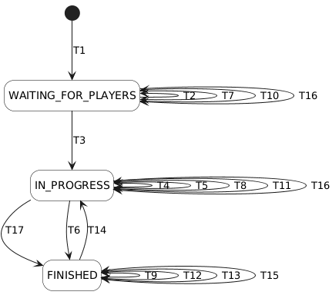
Figure 2 - Created using https://editor.plantuml.com/

5.3.4. Turn-taking Semantics
Turn-taking semantics define the formal rules which govern:
- The participant who is authorised to submit an action
- When that action is considered valid
- How actions affect the authoritative game state
- How ordering and concurrency are controlled
These rules ensure deterministic progression of the shared state and prevent conflicting or out-of-order updates.

5.3.4.1. Authoritative Turn Ownership
At any point during the IN_PROGESS state, exactly one player is designated as “active”, defined by:
TurnColour ∈ {white, black}

5.3.4.2. Valid Move Conditions
A MOVE_SUBMIT message is accepted if all of the following conditions hold:
- Current system state is: IN_PROGRESS
- The sender is assigned a colour
- The sender’s colour matches current turn (turnColour)
- expectedRevision == revision
- The move is legal under official chess rules
If any condition fails:
- The move is rejected
- The authoritative state does not change
- MOVE_REJECTED is emitted

Turn Progression Rule
To guarantee a deterministic ordering of actions, after a valid move:
- revision++
- turnColour = opposite turnColour

5.3.4.4 Revision-Based Ordering Control
The inclusion of expectedRevision in MOVE_SUBMIT enforces optimistic concurrency (https://www.freecodecamp.org/news/how-databases-guarantee-isolation/), which prevents:
- Duplicate submissions
- Out-of-order message processing
- Late packets modifying state
If: expectedRevision != revision, the move is rejected as STALE_REVISION

Terminal Condition Override
If a move results in checkmate or stalemate:
state = FINISHED, no further MOVE_SUBMIT messages are valid in this state.

5.3.4.6 Rematch Reset Rule
Semantics are reset if both players accept a rematch:
- fen = START_FEN
- revision = 0
- turnColour = white
- state = IN_PROGRESS

5.3.5. Sequencing Rules
Message sequencing rules define the valid chronological ordering of client-server interactions, they ensure that:
- Messages are only processed in appropriate states
- Invalid message ordering is rejected deterministically
- The system maintains consistency (despite asynchronous messaging)

5.3.5.1 Message Legality (based on current state)
If a prohibited message is received: ERROR: INVALID_MESSAGE_FOR_STATE
1. WAITING_FOR_PLAYERS
Legal messages: GAME_CREATE, GAME_JOIN, DISCONNECT, RECONNECT
Rejected: MOVE_SUBMIT, REMATCH_REQUEST, REMATCH_DECLINE, RESIGN
2. IN_PROGRESS
Legal messages: MOVE_SUBMIT, DISCONNECT, RECONNECT, RESIGN
Rejected: GAME_JOIN, REMATCH_REQUEST, REMATCH_DECLINE
3. FINISHED
Legal messages: REMATCH_REQUEST, REMATCH_DECLINE, RECONNECT
Rejected: MOVE_SUBMIT, RESIGN

5.3.5.2 Message Ordering Within a Turn
Within IN_PROGRESS, message ordering must respect:
revision_n < revision_(n+1)
Each valid move increments revision monotonically (always +1).
A move referencing a stale revision is rejected:
expectedRevision != currentRevision → reject
This prevents late-arriving messages, duplicate submissions, out-of-order execution

5.3.5.3 Single Active Move Constraint
At most, one valid MOVE_SUBMIT transition may be applied per revision value.
This allows for serialisability of game progression

5.3.5.4 Rematch Sequencing Constraint
REMATCH_REQUEST is valid only in FINISHED, additionally:
- Both players must submit REMATCH_REQUEST
- The second acceptance triggers state reset
- A REMATCH_DECLINE clears rematch flag from both players
Rematch messages received in any other state result in:
ERROR: REMATCH_NOT_AVAILABLE

5.3.5.5 Reconnection Ordering
RECONNECT (which can occur in any state):
- Does not change state
- Does not change revision
- Always results in: STATE_SYNC

5.3.5.6 Determinism Guarantee
Given identical message sequence, the system must produce identical resulting states. This is achieved through:
- Centralised validation
- Strict revision enforcement
- State-dependent message admissibility

5.3.6. Error Handling
Errors are grouped into seven categories:

5.3.6.1 State Violation Errors
Occurs when a message is not valid for current state, for example:
- MOVE_SUBMIT during WAITING_FOR_PLAYERS
- REMATCH REQUEST during IN_PROGRESS
- GAME_JOIN during IN_PROGRESS
Response: ERROR: INVALID_MESSAGE_FOR_STATE

5.3.6.2 Turn Authority Errors
Occurs when a player attempts to act out of turn, for example: black player submits a move while turnColour = white
Response: MOVE_REJECTED: NOT_YOUR_TURN

5.3.6.3 Revision Mismatch Errors
Occurs when expectedRevision != current revision
Response: MOVE_REJECTED: STALE_REVISION

5.3.6.4 Illegal Move Errors
Occurs when a move violates official chess rules.
Response: MOVE_REJECTED: ILLEGAL_MOVE

5.3.6.5 Rematch Availability Errors
Occurs when: REMATCH_REQUEST or REMATCH_DECLINE received outside FINISHED
Response: ERROR: REMATCH_NOT_AVAILABLE

5.3.6.6 Disconnection
When a client disconnects:
- The authoritative state is preserved
- Player connection status is updated
- PLAYER_LEFT is emitted
- Game termination does not immediately occur
When a client reconnects:
- Latest authoritative snapshot is transmitted
- Revision remains unchanged

6. Message Catalogue

6.1. HELLO
Summary
Sender: Client
Recipient: Server
Purpose: Register a newly connected socket and begin protocol interaction
Valid States
- NO_SESSION
- WAITING_FOR_PLAYER
- IN_PROGRESS
- FINISHED
Required Envelope Fields
- type
- clientMsgId
- clientTimeMs
Required Payload Fields
- payload.clientId
Optional Payload Fields
- payload.playerId
- payload.gameId
Successful Responses
- WELCOME
Failure Responses
- ERROR
Notes
- HELLO should be processed before gameplay messages
- It establishes client/socket identity at the protocol level
- It may also support reconnect scenarios in later versions
Example
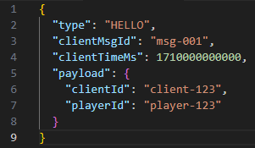

6.2. WELCOME
Sender: Server
Recipient: Client
Purpose: Confirm successful handshake and socket registration
Valid States
- Not state-dependent
Required Fields
- type
- serverTimeMs
Optional Fields
- correlationMsgId

Typical Payload Fields
- payload.socketId
- payload.clientId
- payload.playerId
- payload.message

Successful Responses
- N/A
Failure Responses
- N/A
Notes
- Usually sent in response to HELLO
- Should include correlationMsgId matching the original clientMsgId.

6.3. GAME_CREATE
Sender: Client
Recipient: Server
Purpose: Create a new game session
Valid States
- NO_SESSION
Required Fields
- type
- clientMsgId
- clientTimeMs
Required Payload Fields
- None
Optional Payload Fields
- Payload.password
- Payload.
Successful Responses
- GAME_CREATED
- STATE_SYNC
Failure Responses
- ERROR
Notes
- Creates a new game in WAITING_FOR_PLAYERS
- Initial FEN should be standard starting position
- Initial revision should be 0
- turnColour should be null until the second player joins

6.4. GAME_CREATED
Sender: Server
Recipient: Client
Purpose: Confirm game creation
Valid States
- Not state-dependent
Required Fields
- type
- serverTimeMs
Typical Payload Fields
- payload.gameId
- payload.assignedColour
Optional Payload Fields
- correlationMsgId
Successful Responses
- N/A
Failure Responses
- N/A
Notes
- Usually followed by STATE_SYNC
- Sent only to the creating client

6.5. GAME_JOIN
Sender: Client
Recipient: Server
Purpose: Join an existing game session
Valid States
- WAITING_FOR_PLAYERS
Required Fields
- type
- clientMsgId
- clientTimeMs
Required Payload Fields
- payload.gameId
Successful Responses
- GAME_JOINED
- GAME_START
- STATE_SYNC
Failure Responses
- ERROR
Notes
- Rejected if game does not exist
- Rejected if game already has two players
- Assigns the client to the remaining colour
- Does not itself represent move submission readiness; GAME_START does that

6.6. GAME_JOINED
Sender: Server
Recipient: Client
Purpose: Confirm successful join
Valid States
- Not state-dependent
Required Fields
- type
- serverTimeMs
Typical Payload Fields
- payload.gameId
- payload.assignedColour
Optional Fields
- correlationMsgId
Successful Responses
- N/A
Failure Responses
- N/A
Notes
- Sent only to the joining player

6.7. GAME_START
Sender: Server
Recipient: Both players (clients) in one game
Purpose: Notify that both players
Valid States
- Not state-dependent
Required Fields
- type
- serverTimeMs
Typical Payload Fields
- payload.gameId
- payload.turnColour
Successful Responses
- N/A
Failure Responses
- N/A
Notes
- Sent after the second player joins and the internal state transitions to IN_PROGRESS
- Initial turnColour should be white

6.8. STATE_SYNC_REQUEST
Sender: Client
Recipient: Server
Purpose: Request the latest full authoritative state
Valid States
- WAITING_FOR_PLAYERS
- IN_PROGRESS
- FINISHED
Required Fields
- type
- clientMsgId
- clientTimeMs
Required Payload Fields
- payload.gameId
Successful Responses
- STATE_SYNC
Failure Responses
- ERROR
Notes
- Primarily used for reconnect/recovery
- Must not change state or revision
- Server should return the latest authoritative snapshot

6.9. STATE_SYNC
Sender: Server
Recipient: Client or both players
Purpose: Send the full authoritative game/session state
Valid States
- Not state-dependent
Required Fields
- type
- serverTimeMs
Typical Payload Fields
- payload.gameId
- payload.state
- payload.revision
- payload.fen
- payload.turnColour
Optional Payload Fields
- payload.players
- payload.moveHistory
- payload.result
Successful Responses
- N/A
Failure Responses
- N/A
Notes
Used after creation, join/start, reconnect, and resync scenarios
Example 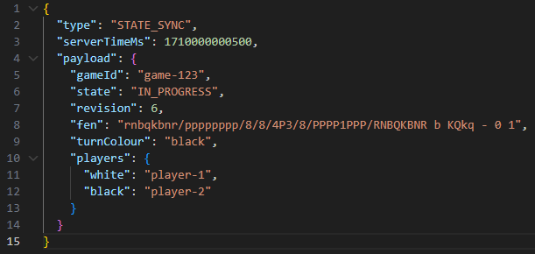

6.10. MOVE_SUBMIT
Sender: Player client
Recipient: Server
Purpose: Submit a move in UCI format
Valid States
- IN_PROGRESS
Required Fields
- type
- clientMsgId
- clientTimeMs
Required Payload Fields
- payload.gameId
- payload.expectedRevision
- payload.uci
Successful Responses
- MOVE_ACCEPTED
- STATE_UPDATE
- GAME_CONCLUDED (if terminal)
Failure Responses
- MOVE_REJECTED
- ERROR
Notes
- expectedRevision must match the authoritative server revision exactly
- The sender must belong to the game
- The sender must be the player whose turn it is
- The move must be legal according to chess rules
- Duplicate submissions for the same clientMsgId must not be applied twice
- At most, one valid move may be applied for a given authoritative revision value
Example
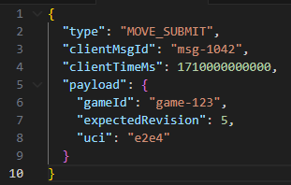

6.11. MOVE_ACCEPTED
Sender: Server
Recipient: Submitting player
Purpose: Confirm that a submitted move was accepted and applied
Valid States
- Not state-dependent
Required Fields
- type
- serverTimeMs
Optional Fields
- correlationMsgId
Required Payload Fields
- payload.gameId
- payload.revision
- payload.uci
Optional Payload Fields
- payload.san
- payload.fen
Successful Responses
- N/A
Failure Responses
- N/A
Notes
- This is a move-specific success acknowledgement
- Usually followed by STATE_UPDATE

6.12. MOVE_REJECTED
Sender: Server
Recipient: Client
Purpose: Reject a move that was well-formed but not valid to apply
Valid States
- Not state-dependent
Required Fields
- type
- serverTimeMs
Required Payload Fields
- payload.gameId
- payload.reason
Optional Payload Fields
- payload.expectedRevision
- payload.currentRevision

Typical Rejection Codes
- NOT_YOUR_TURN
- STALE_REVISION
- ILLEGAL_MOVE
Successful Responses
- N/A
Failure Responses
- payload.details (optional diagnostic info)
Notes
- Use this for move-specific semantic failure, not general protocol failure

6.13. STATE_UPDATE
Sender: Server
Recipient: Both players
Purpose: Broadcast updated authoritative state after an accepted state-changing action, typically a move
Valid States
- Not state-dependent
Required Fields
- type
- serverTimeMs
Required Payload Fields
- payload.gameId
- payload.revision
- payload.state
Optional Payload Fields
- payload.turnColour
- payload.lastMove
- payload.state
Successful Responses
- N/A
Failure Responses
- N/A
Notes
- Should be emitted after a move is applied and persisted
- Represents the latest authoritative post-update state
Example
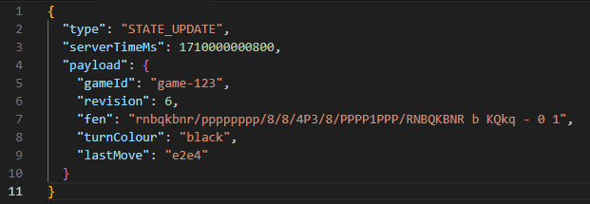

6.14. GAME_CONCLUDED
Sender: Server
Recipient: Both players
Purpose: Notify clients that the game has entered FINISHED state
Valid States
- Not state-dependent
Required Fields
- type
- serverTimeMs
Required Payload Fields
- payload.result
Optional Payload Fields
- payload.reason
- payload.winner
- payload.fen
- payload.revision
Successful Responses
- N/A
Failure Responses
- N/A
Notes
- Sent after terminal conditions such as checkmate, draw, stalemate, or other agreed end states
- Typically accompanied by a final STATE_SYNC or terminal STATE_UPDATE

6.15. PLAYER_LEFT
Sender: Server
Recipient: Client
Purpose: Notify that a player disconnected or left the session
Valid States
- Not state-dependent
Required Fields
- type
- serverTimeMs
Required Payload Fields
- payload.playerId
Optional Payload Fields
- payload.gameId
Successful Responses
- N/A
Failure Responses
- N/A
Notes
- Disconnect should not necessarily destroy the game immediately
- Used to support reconnect-aware behaviour

6.16. ERROR
Sender: Server
Recipient: Client
Purpose: Report general protocol, state, or lifecycle failure
Valid States
- Not state-dependent
Required Fields
- type
- serverTimeMs

Optional Fields
- correlationMsgId
Required Payload Fields
- payload.code
Optional Payload Fields
- payload.message

Typical Error Codes
- INVALID_MESSAGE_FORMAT
- INVALID_MESSAGE_FOR_STATE
- GAME_NOT_FOUND
- GAME_FULL
- DUPLICATE_MESSAGE
- INTERNAL_ERROR
Successful Responses
- N/A
Failure Responses
- N/A
Notes
- Use ERROR for general protocol/state failures
- Use MOVE_REJECTED for move-specific semantic rejection

6.17. REMATCH_REQUEST
Sender: Client
Recipient: Server
Purpose: Request a rematch after a finished game
Valid States
- FINISHED
Required Fields
- type
- clientMsgId
- clientTimeMs
Required Payload Fields
- payload.gameId
Successful Responses
- STATE_SYNC
- Future rematch-specific responses as required
Failure Responses
- ERROR
Notes
- This may be implemented later
- Included in the catalogue because it exists in the planned protocol/state model

6.18. REMATCH_DECLINE
Sender: Client
Recipient: Server
Purpose: Decline a rematch request
Valid States
- FINISHED
Required Fields
- type
- clientMsgId
- ClientTimeMs
Required Payload Fields
- payload.gameId
Successful Responses
- Future rematch-specific responses as required
Failure Responses
- ERROR
Notes
- This may be implemented later
- Included for completeness relative to the planned protocol

6.19 RESIGN
Sender: Client
Recipient: Server
Purpose: Allow a player to voluntarily concede an active game, causing the game to enter the FINISHED state with the resigning player recorded as the loser
Valid States
- IN_PROGRESS
Required Fields
- type
- clientMsgId
- clientTimeMs

Required Payload Fields
- payload.gameId

Successful Responses
- GAME_CONCLUDED
- STATE_SYNC

Failure Responses
- ERROR

Notes
- RESIGN is valid only during IN_PROGRESS
- When accepted, the auth’ game state transitions from IN_PROGRESS to FINISHED

7. Dependency Diagram

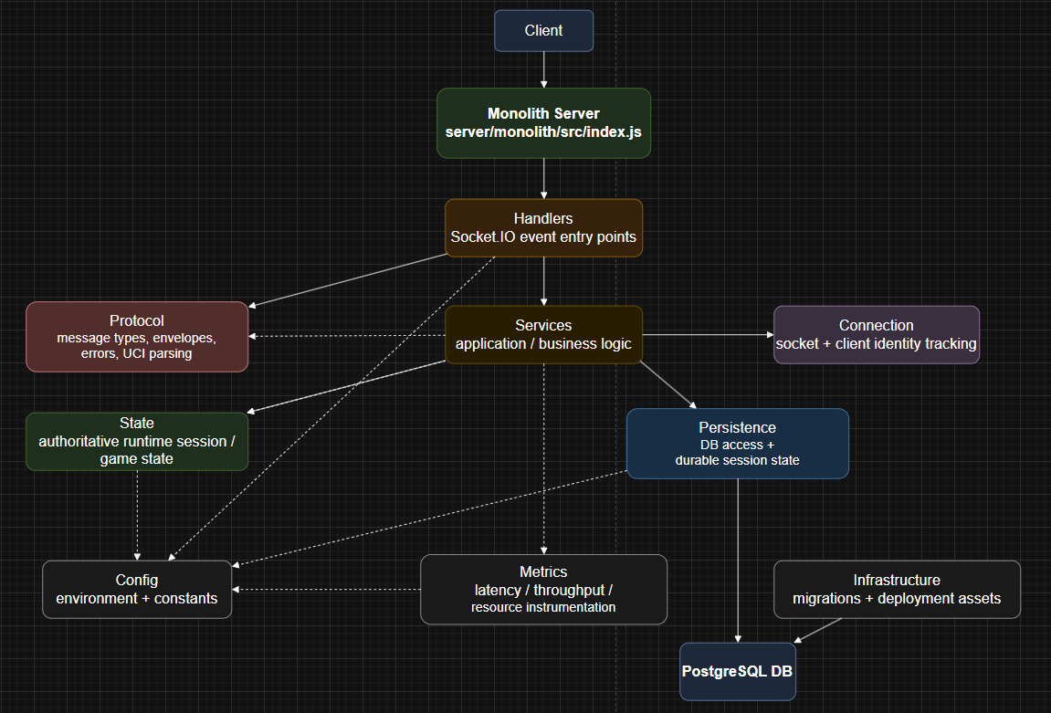

8. Database Entity Relationship Diagram
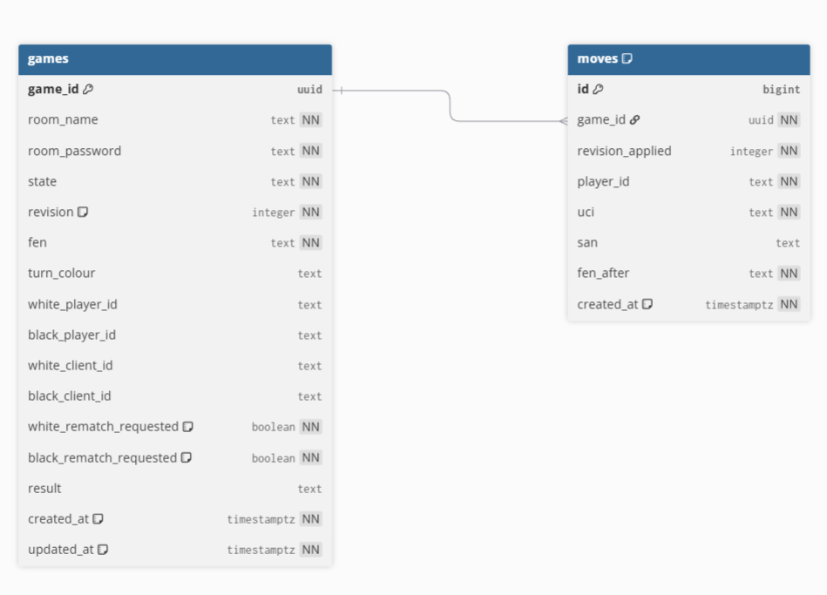

9. Sequence Diagrams

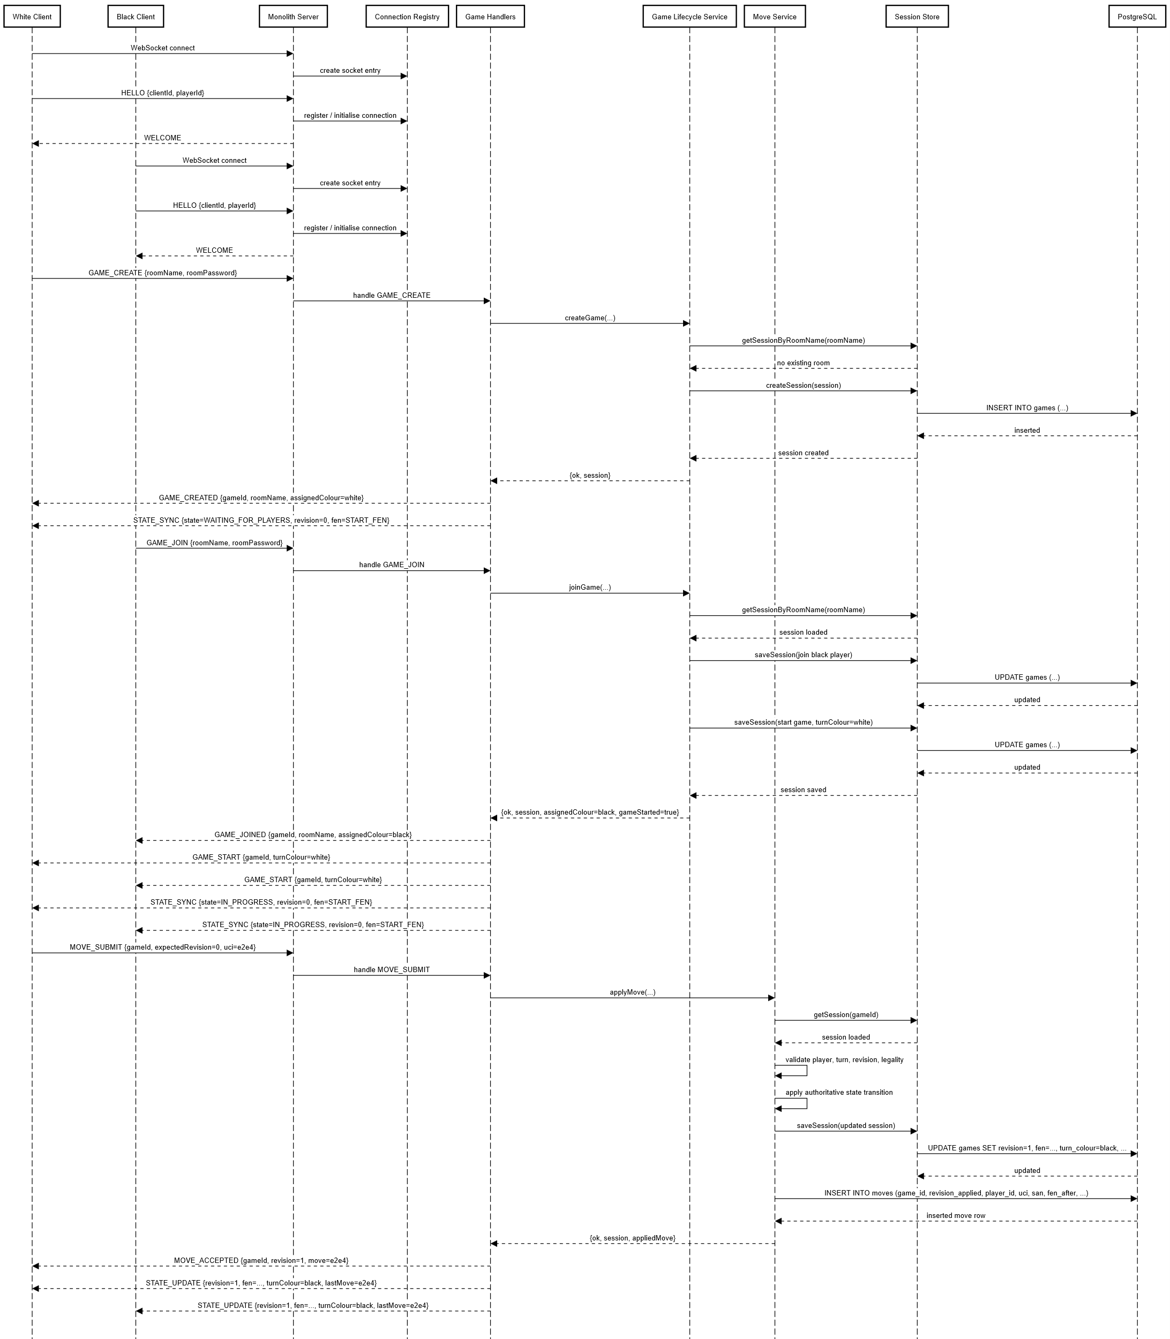
9.1. Full Detail

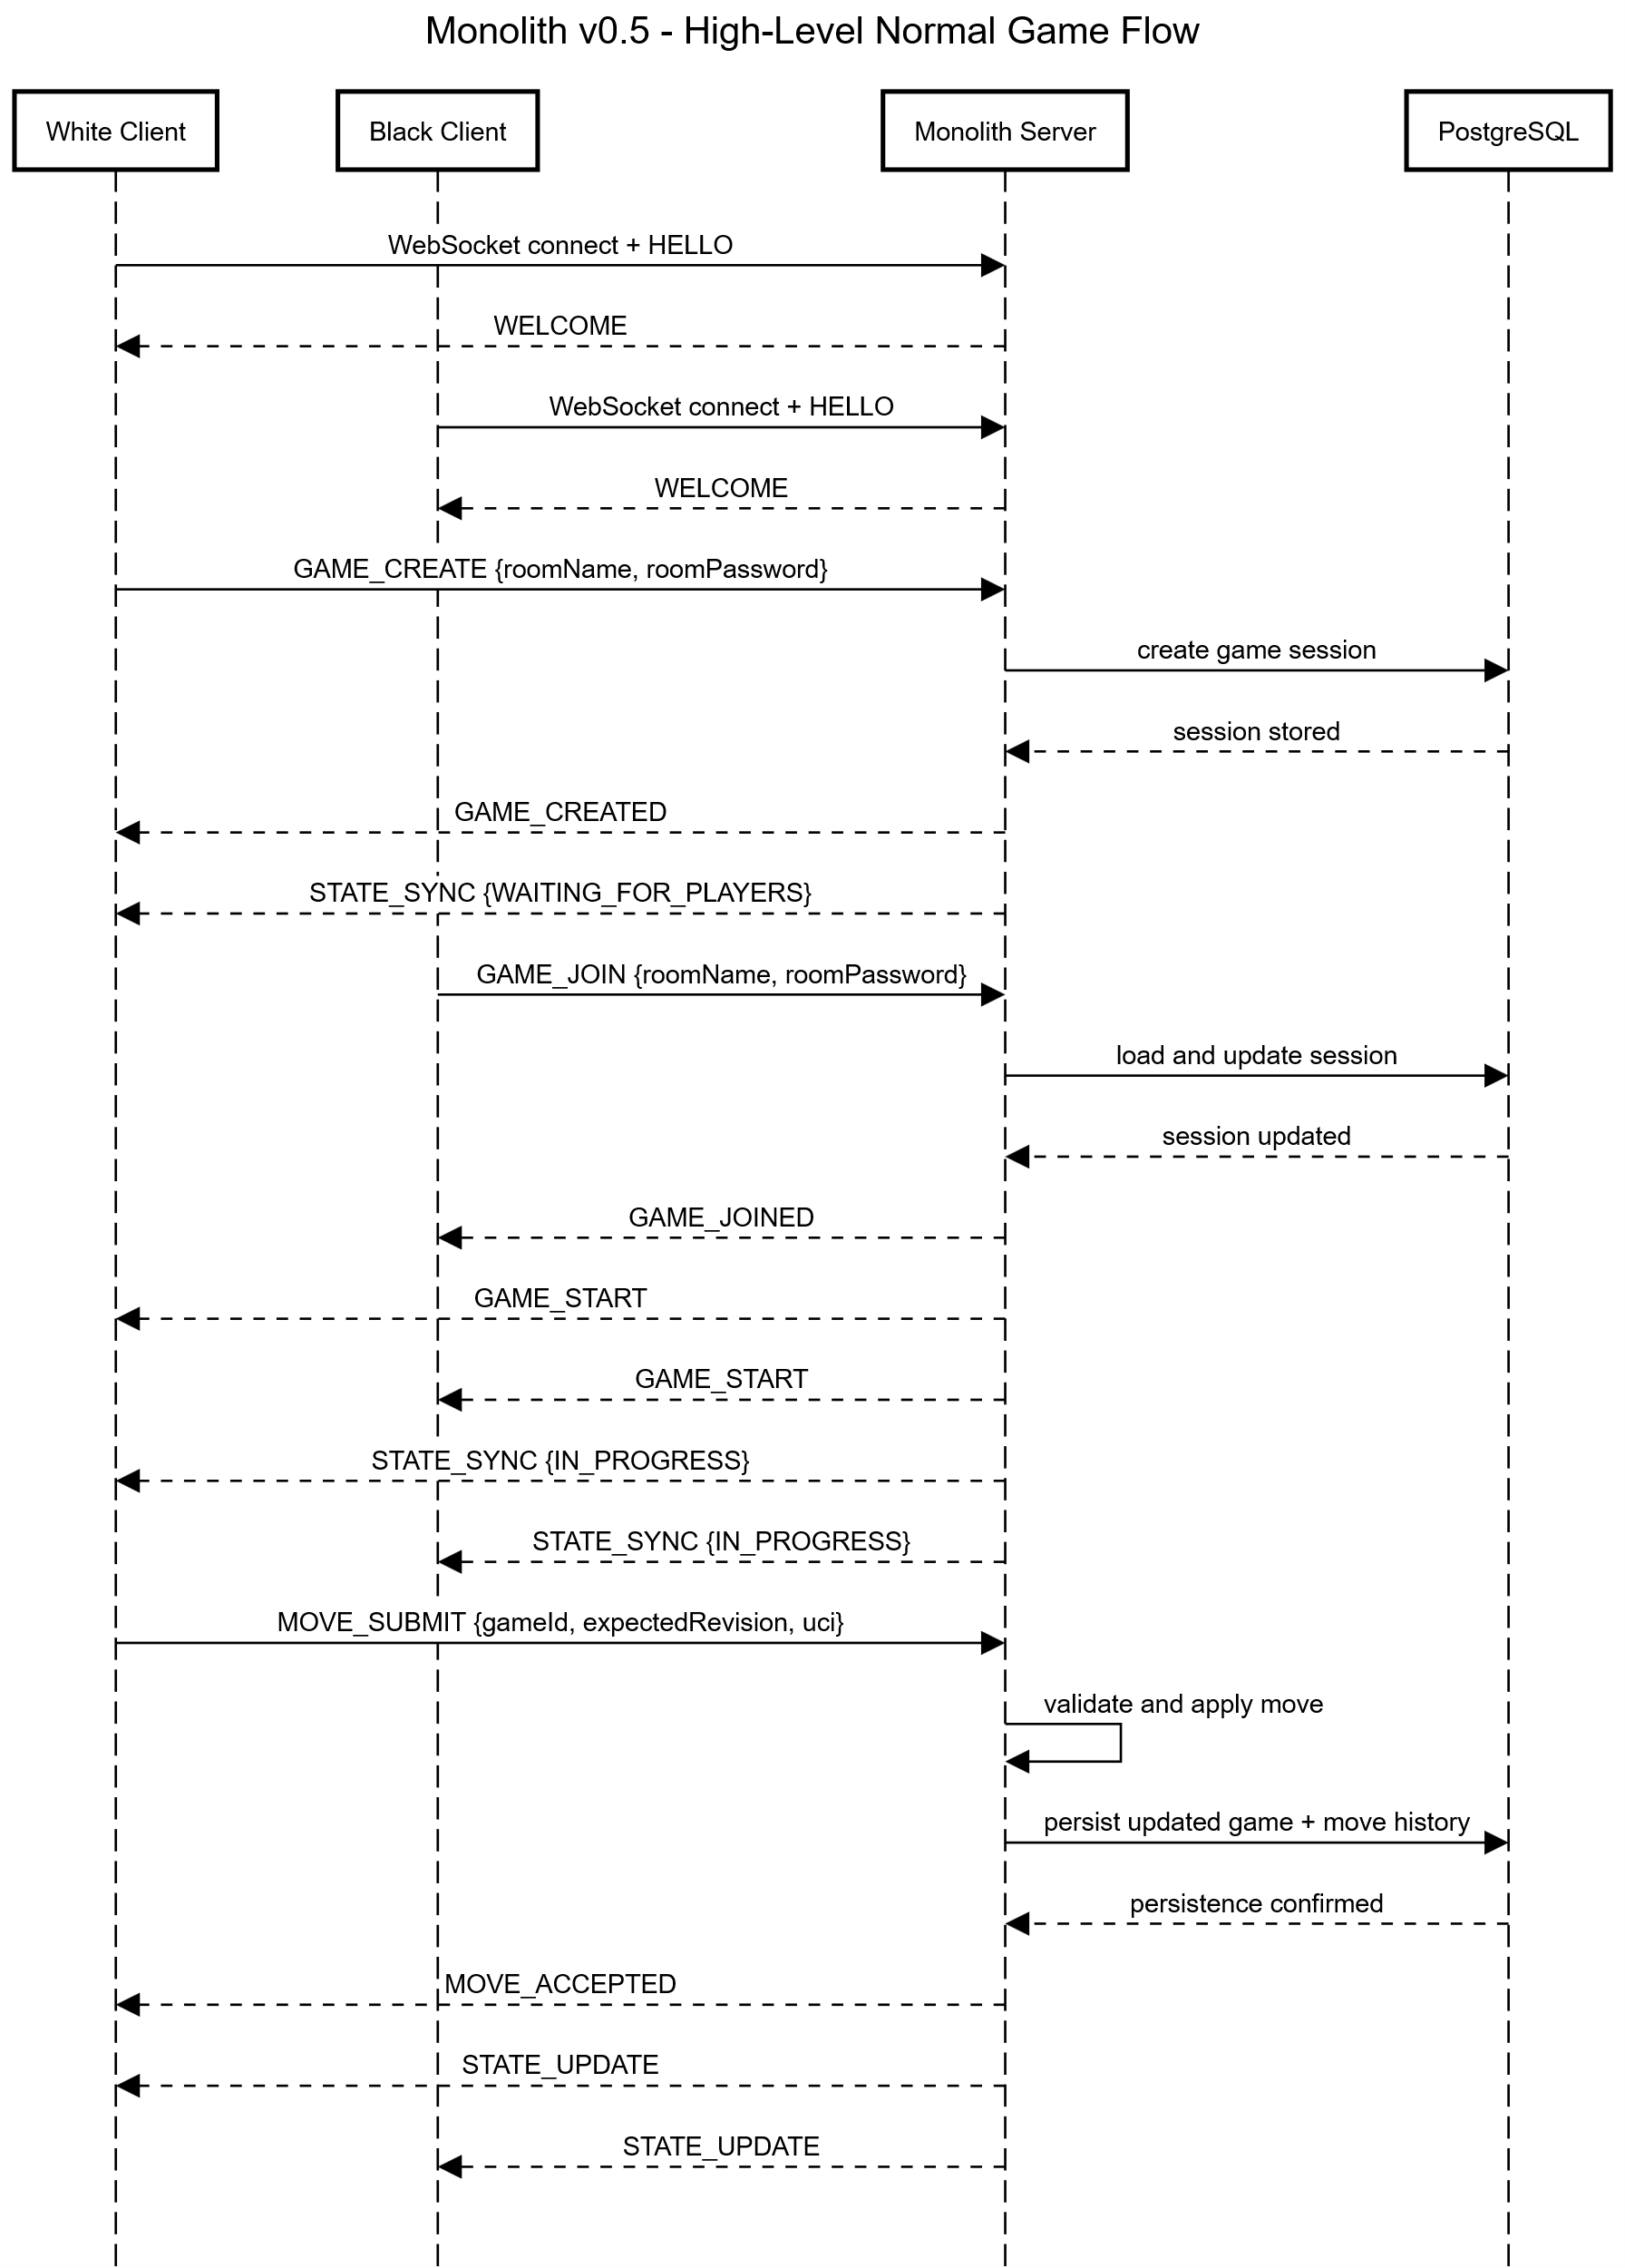
9.2 High-level

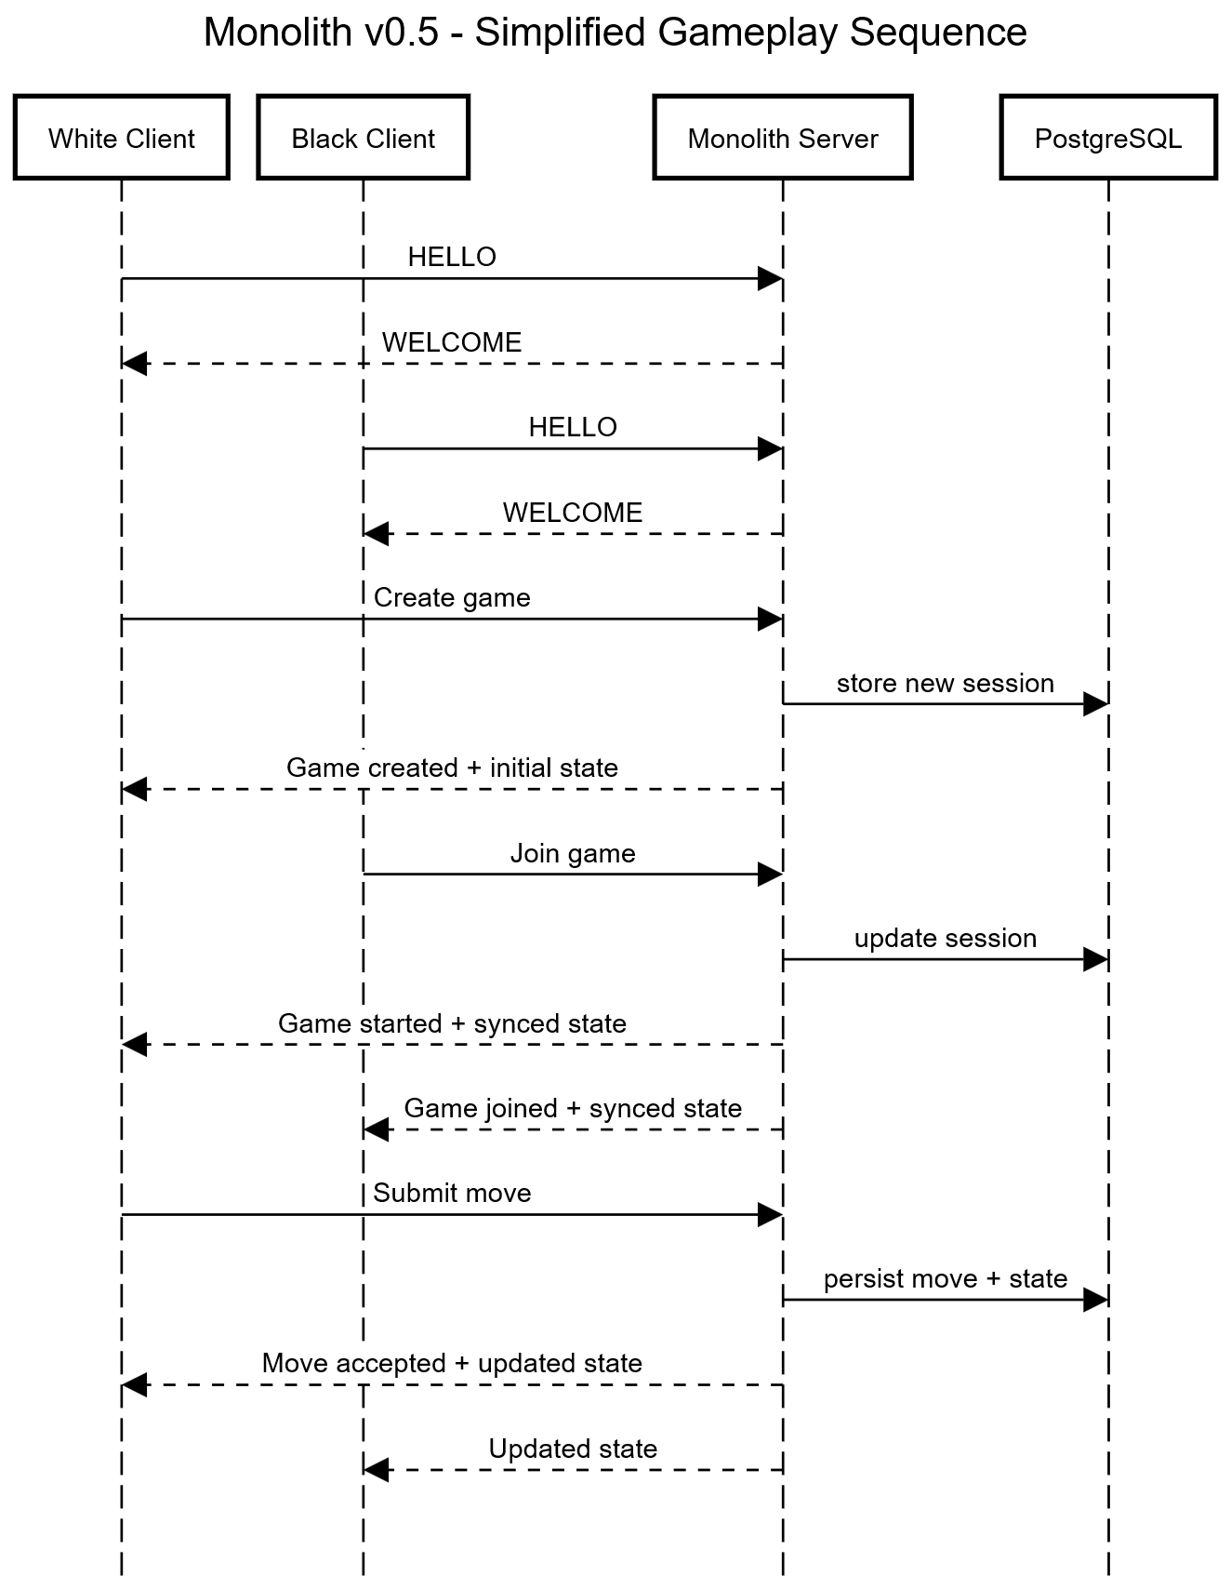
9.3 Simplified

9.4 Full Detail (decomposed into 4 phases)
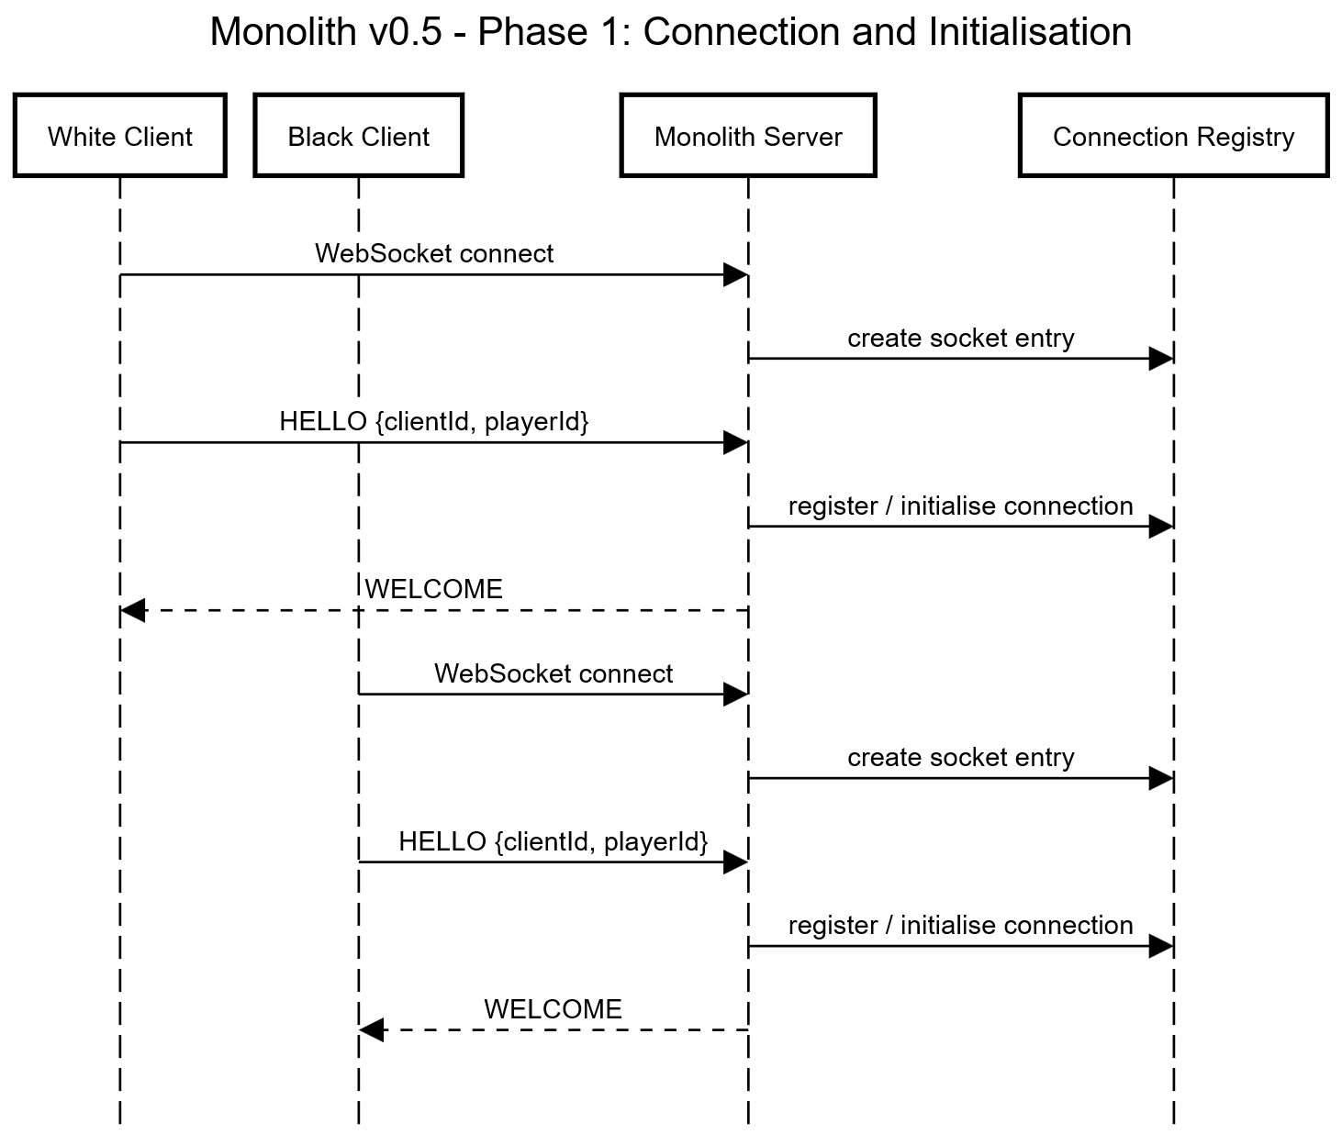

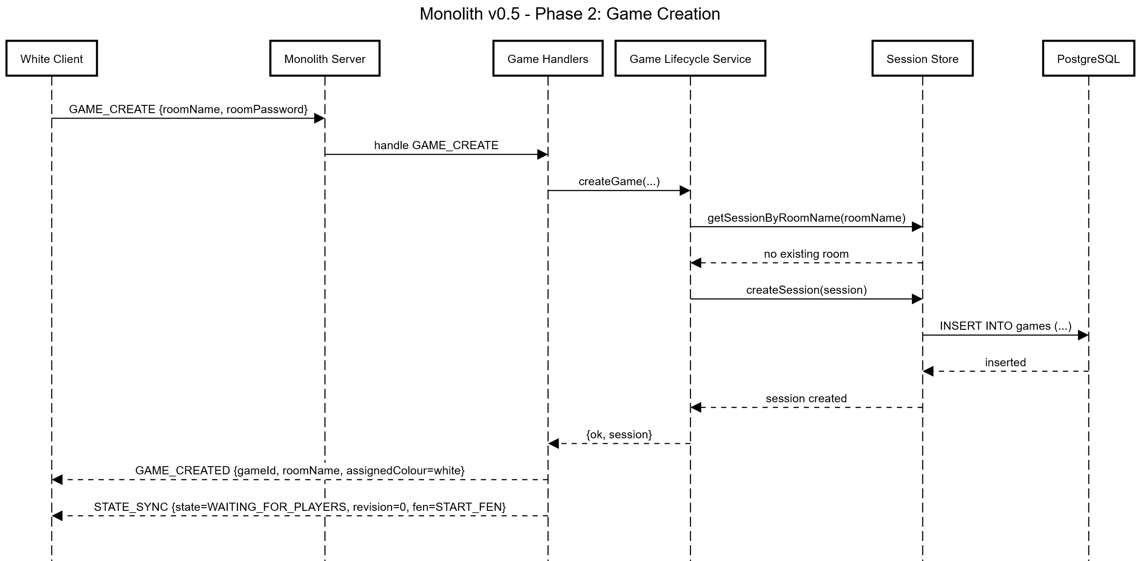

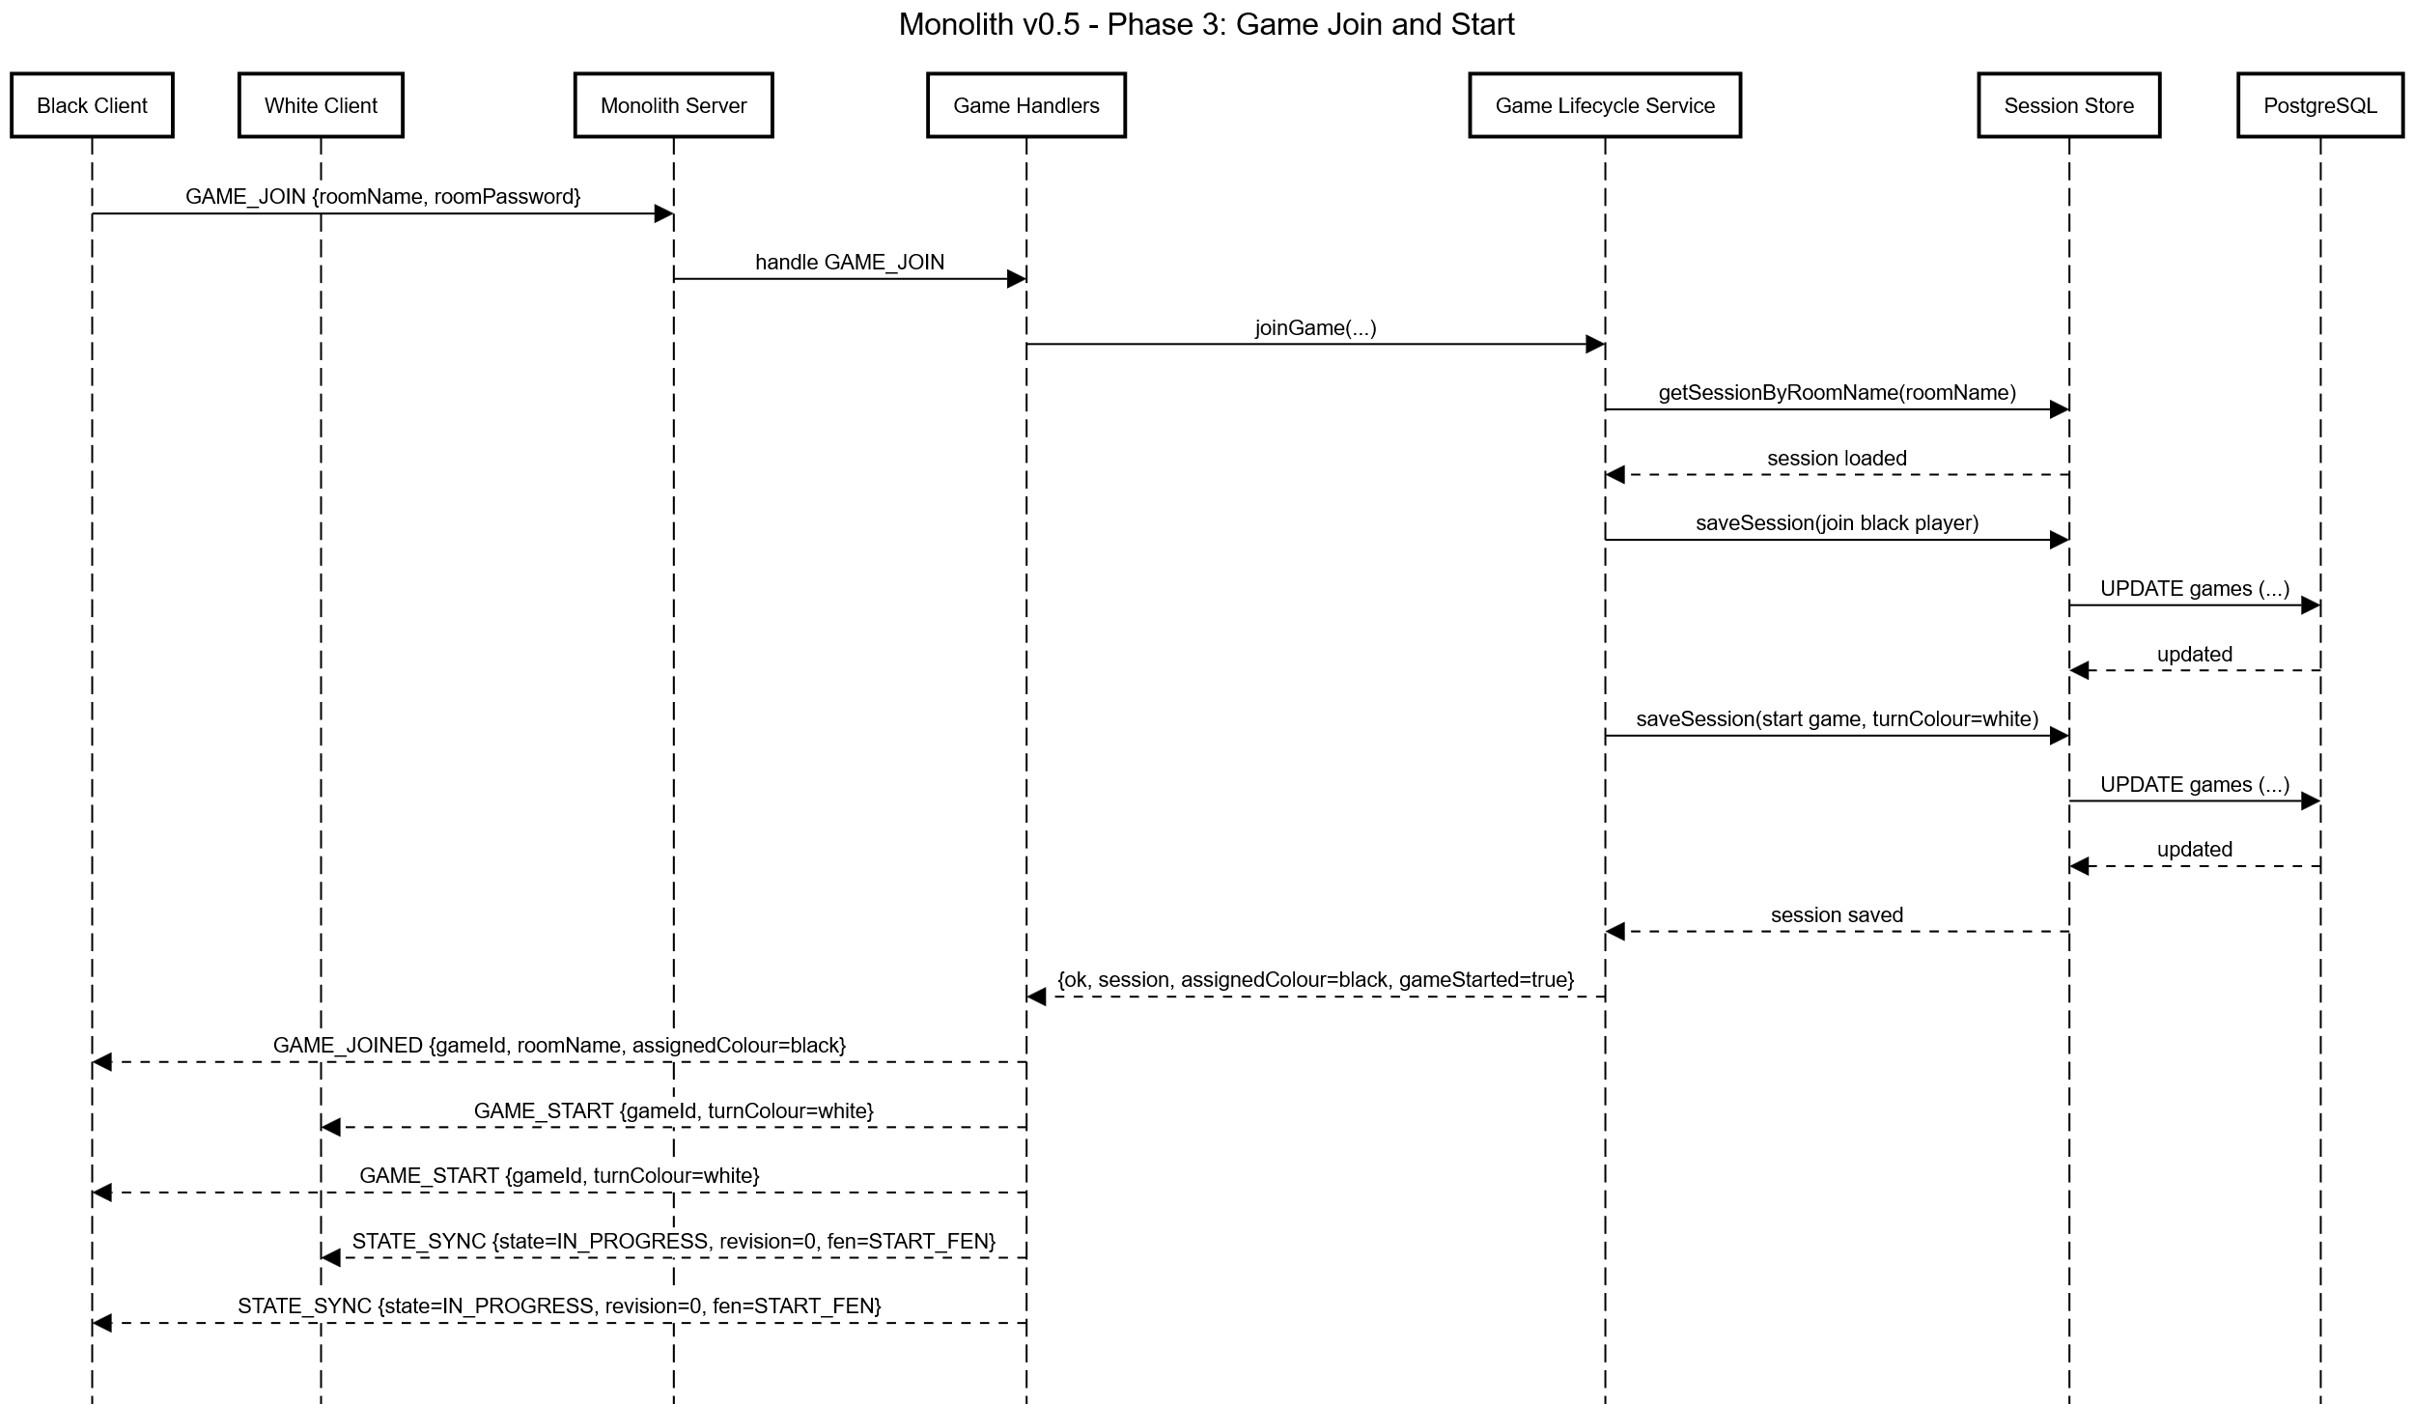
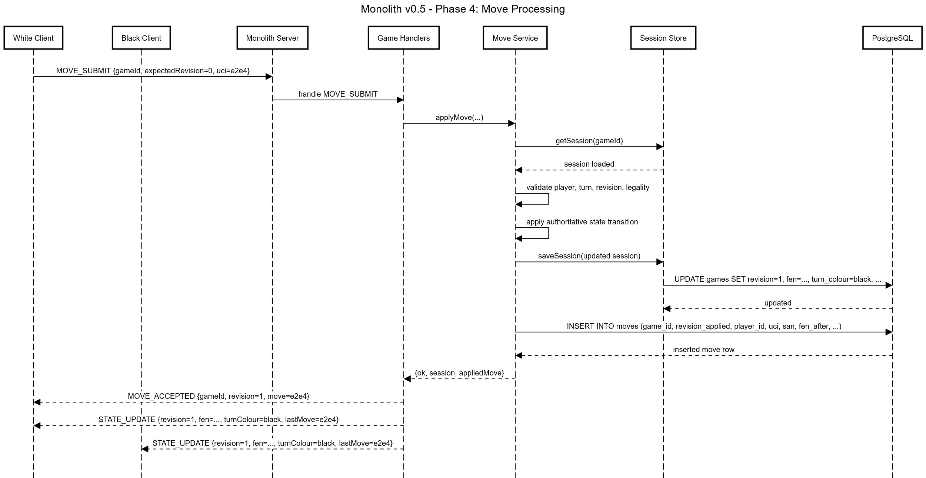

10. Evaluation Requirements

10.1. Workloads
Deterministic benchmark workloads using predefined move sequences.
Probabilistic workloads incorporating:
- Variable think times
- Simulated disconnections
- Invalid and out-of-order message injection#
Concurrency levels:
- Baseline (1-5 games)
- Moderate (10-25 games)
- High (50+ games, subject to system limits)
Fault scenarios:
- Service termination at restart
- Client disconnection and reconnection
- Artificial network delay injection

10.2. Metrics Collection
- Latency: move submission to state update propagation (p50, p95, p99)
- Throughput: moves processed per second
- Resource Utilisation: CPU usage and memory consumption
- Consistency and Correctness: state divergence (expected = 0), and rejection by error type
- Fault Recovery: reconnection success rate, and recovery time after restart

11. Limitations
- The system is evaluated in a controlled, non-cloud environment, which may not fully capture real-world deployment variability
- Workloads are partially synthetic, using simulated clients and replayed game data rather than human participants
- All experiments are conducted on a single hardware platform, limiting generalisability across heterogeneous environments
- Network conditions are simulated rather than derived from real-world internet

